**Exercise 1 : Implementation of Singleton Pattern**

**Code** :

1. **Logic Code For Singleton Pattern :**

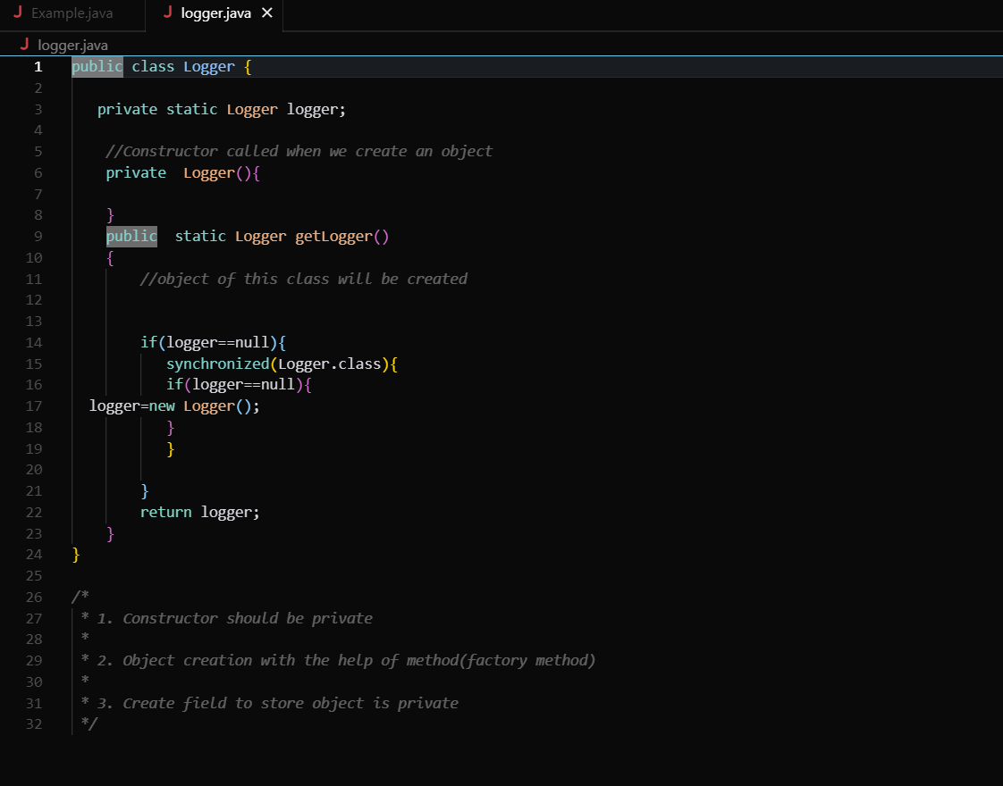

1. **Implementation Code of Singleton Pattern :** Here, we are checking whether the two created objects share the same parent class.

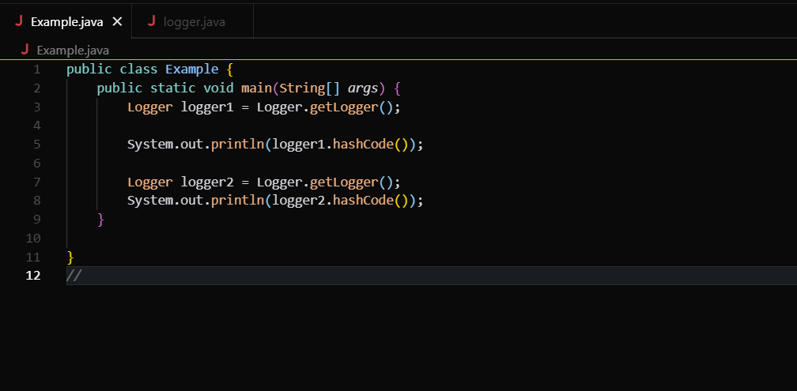

**Output** :

